**Split It**

**User manual**

**Introduction**

Split It is a finance app that targets young mobile people with active and interactive economic lives. Whether you want to split a tab, pay your part of a group expense or keep track of mutual debts, Split It is the app for you. With the possibility to invite your contacts to share a tab or an economic event it’s easy to organize your joint payment. When your contacts accept the invite the mutual debts are automatically recalculated. The ease of use is what will make you want to use it – every day.

This user manual is a guide on how to use the Split It Android application.

**System requirements**

* Java 4 SE development environment
* Android SDK
* Android device (physical or virtual)
* Android SDK targets
* *Minimum SDK: 16*
* *Target SDK: 18*

**Installation**

1. Visit <https://github.com/wisingd/Dajoroli>.
2. Fork your own copy of wising/Dajoroli to your GitHub account.
3. Start Eclipse or another Java 4 development environment.
4. Import the project folder of Split It.
5. Connect your Android device to the computer.
6. Run the application in Eclipse or another Java 4 development environment.

**Overview**

**Main sections**

When Split It is started after installed, you will enter the main menu of the application. In this menu, you can choose between three different categories. Press the “**Events**” button to create and show events. Press the “**Debts**” button to split, add or remove debts and owings. Press the “**Contacts**” button to add, view and edit contacts.

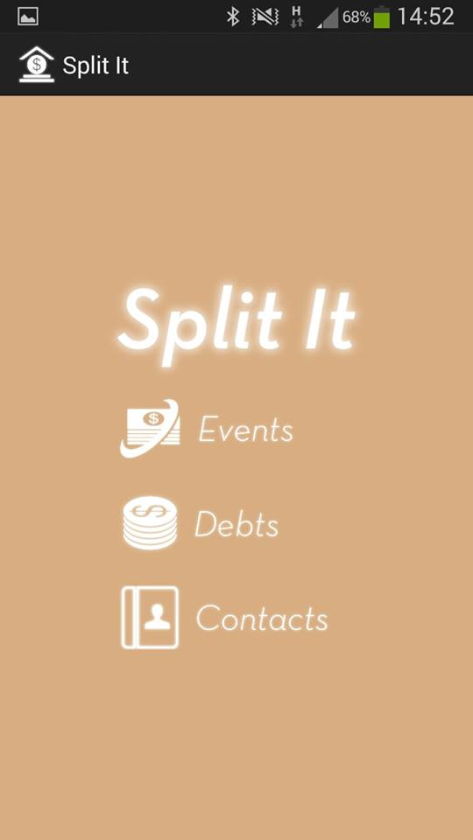**Events**

Add, view and edit contacts.

Split, add or remove debts and owings.

Create and show events

To create a new event, press the “**Date**” button. Please choose the date of when the event took place. Press the “**OK**” button. Press the “**Create**” button. Type in a name for the event. Press the “**OK**” button”. Specify the cost of the event. Press the “**OK**” button. Check the boxes on the right side of the contacts name to choose who participated in the specific event. Press the “**OK**” button. Press the next “**OK**” button. The event is now created.

To show a list of your event, press the “**Show events**” button. A list of your added events will now appear. Press the name of the event you would like to read more about. This will show you what date the event took place, what the total cost was and who participated. To delete the event, press the “**Delete**” button and then the “**Yes**” button. If you don't want to delete the event, then press the “**OK**” button.

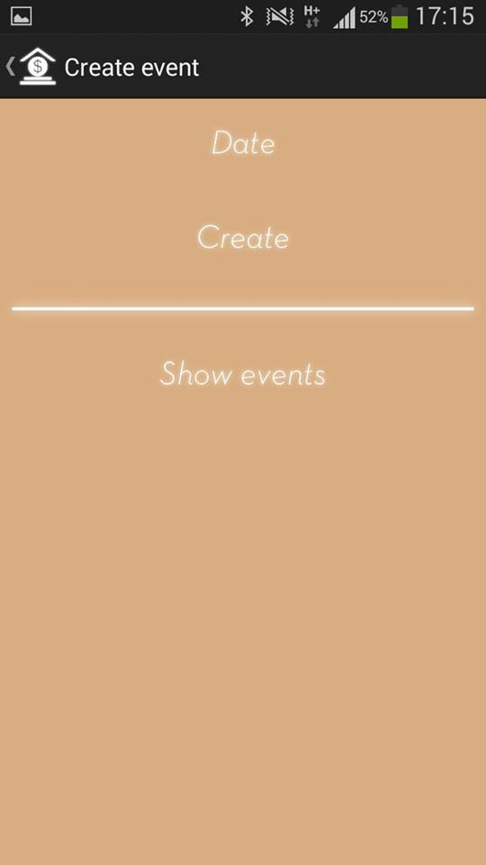**Debts**

Show the list of all your events to get detailed information about and manage events.

Create an event at the specific date.

Choose the date of the event.

To add a new debt someone else has to you, press the “**They owe me**” button. Choose the contact/contacts who owe you money by checking the boxes to the right of the name/names. Press the “**Next**” button. Specify the debt you want to add to this/these specific contact/contacts. Press the “**Next**” button. Press the “**Yes**” button to confirm that you want to add a new debt to this/these contact/contacts. Press “**Yes**” if you would like to notify this/these contact/contacts about the changes you have made. Press “**No**” if you would not like to notify this/these contact/contacts about the changes you have made.

To add a new debt you have to someone else, press the “**I owe them**” button. Press on the name of the person you owe money. Specify the debt you have to this contact. Press the “**OK**” button. Press the “**Yes**” button to confirm that you want to add a new owing to this contact.

To even a debt, i.e. delete a debt, press the “**Even a debt**” button. Choose the contact/contacts debt/debts that you would like to even by checking the boxes to the right of the name/names. Press the “**OK**” button. Press the “**Yes**” button to confirm that you want to even the debt to this/these contact/contacts.

To show the contact list, press the button with the contact icon.

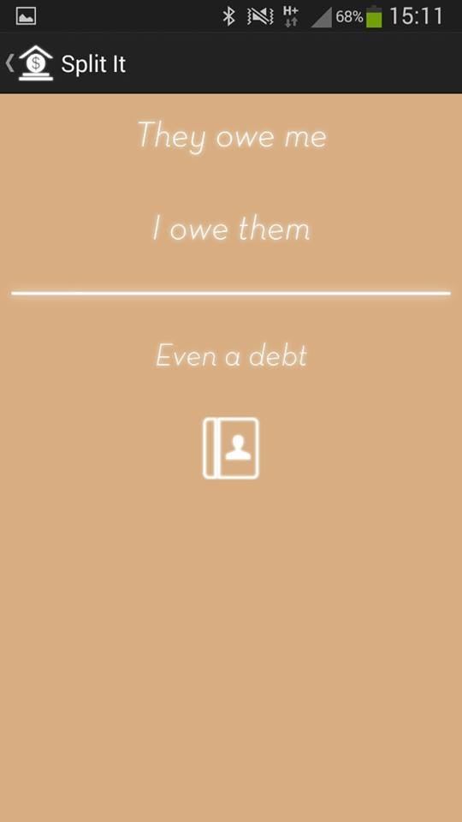**Contacts**

Add a debt/debts that a contact/contacts owe you.

Add a debt that you have to someone else.

Even/delete a debt.

Show the contact list.

To add a new contact, press the “**New...**” button. Type in the name of your new contact. Press the “**Next**” button. If you would like to add a phone number connected to your new contact, press “**Yes**”, type in the phone number and press “**Next**”. Confirm that you want to add the contact with this phone number by pressing “**Yes**” and then press “**OK**”. If you would not like to add a phone number to your new contact, press “**No**” on the question if you would like to add a phone number. Confirm by pressing “**Yes**” that you want to add this contact without any phone number and then press “**OK**”.

To view your current contacts, press the “**View contacts**” button. This will show you a list of the contacts you have added, and how much you owe them or they owe you. Press the “**OK**” button.

To edit contacts, press the “**Edit contacts**” button. If you would like to erase contacts, press the “**Erase contacts**” button. Then choose if you would like to erase all or some contacts by pressing on either the “**Choose**” button or the “**Erase all**” button. If you choose who you want to erase, check the boxes on the right of the contacts name that you would like to erase. Then press the “**Erase button**”. If you press on the “**Erase all**” button, then press on the “**Yes, I'm sure**” button to confirm that you want to erase all your contacts. To edit a contacts phone number, press the “**Edit number**” button on the first pop up window. Press the name of the contact of which you would like to change the phone number. Type in the new phone number and press the “**Change**” button. Confirm this change by pressing the “**Yes**” button.



Erase some or all contacts, or change the phone number of a specific contact.

View a list of your current contacts.

Add a new contact.

**Contact details**

Linn Hansen – linnhan@student.chalmers.se

Robin Jensen – robinje@student.chalmers.se

Johannes Rehnberg - johreh@student.chalmers.se

Daniel Wising – wisingd@student.chalmers.se